24. Draw Isogons
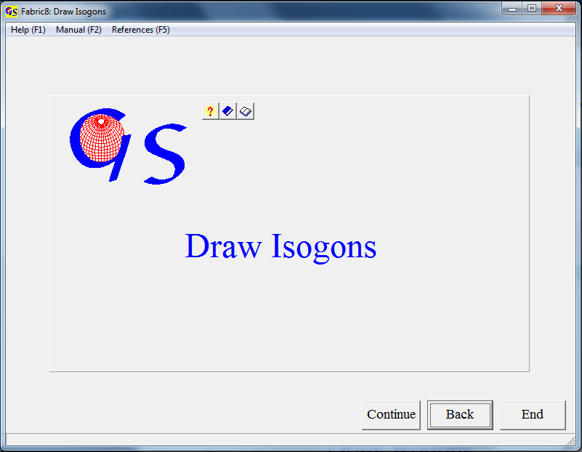
Fig. 1
With this program (Fig. 1) you can draw dip isogons (Ramsay, 1967, p. 365) into a fold profile. A picture of the fold profile must exist as *.bmp, *.gif, *.tif, *.jpg, *.wmf, *.emf, or *.png file, or the picture must be on the clipboard.
The button "Continue" brings you to the graphic form, in which the isogons will be drawn. After pressing the button "Start" and opening the menu "Import picture" you have the option to import the image from a file or from the clipboard (Fig. 2). Either choose 'Whole picture' or 'Cut out' from the menu "Cut out". To cut out a rectangle from the image click on the upper left edge and on the lower right edge.
The median surface of the fold is brought to a horizontal position by clicking on two inflection points of the same folded surface with the left mouse button. The fold rotates now (Fig. 3).
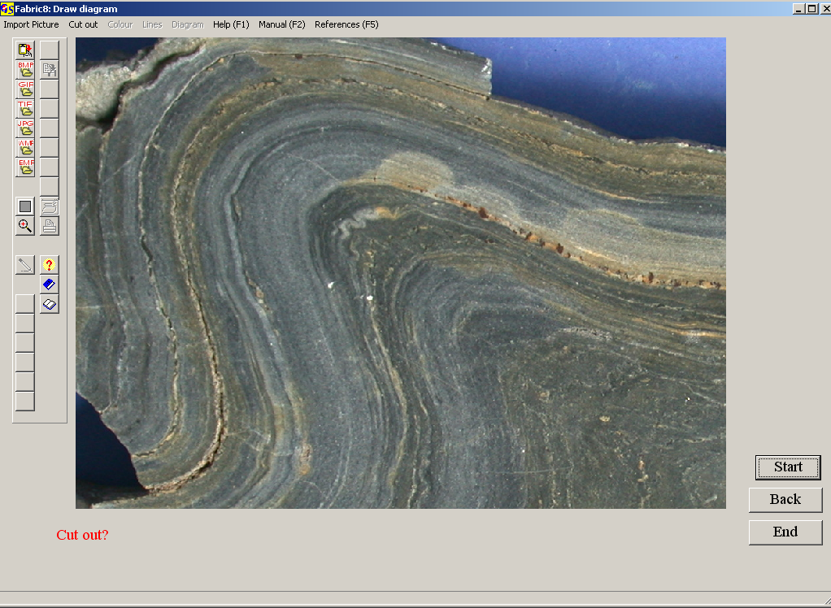
Fig. 2
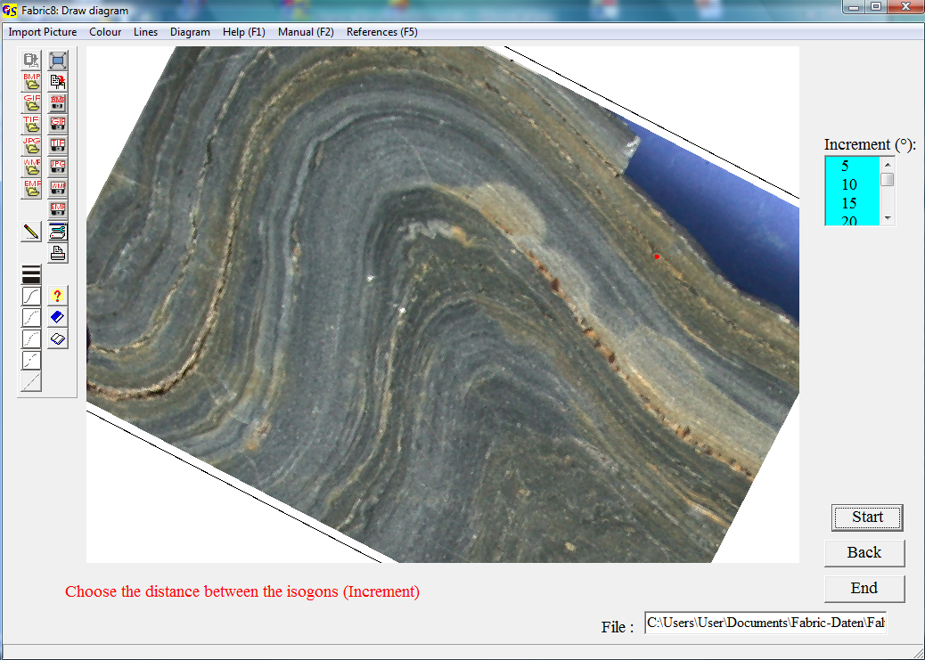
Fig. 3
Now choose the distance between the isogons and press either the button "Clockwise isogons" or "Anticlockwise isogons" (Fig. 4) and choose the pen width from the list. Colour and line type can be defined in the menue "Lines". Other line types than solid are only possible with a pen width of 1.

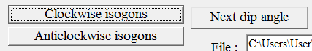
Fig. 4
Choose the distance between the isogons from the list. The 0°-tangent is produced by the program. Let this tangent touch the first folded surface and click with the left mouse-button. Click on the tangential points of all the other surfaces of the fold. Press “Next dip angle” to go to the next isogon.
The graphic can be saved or printed at any time. Fig. 5 shows the resulting isogons.
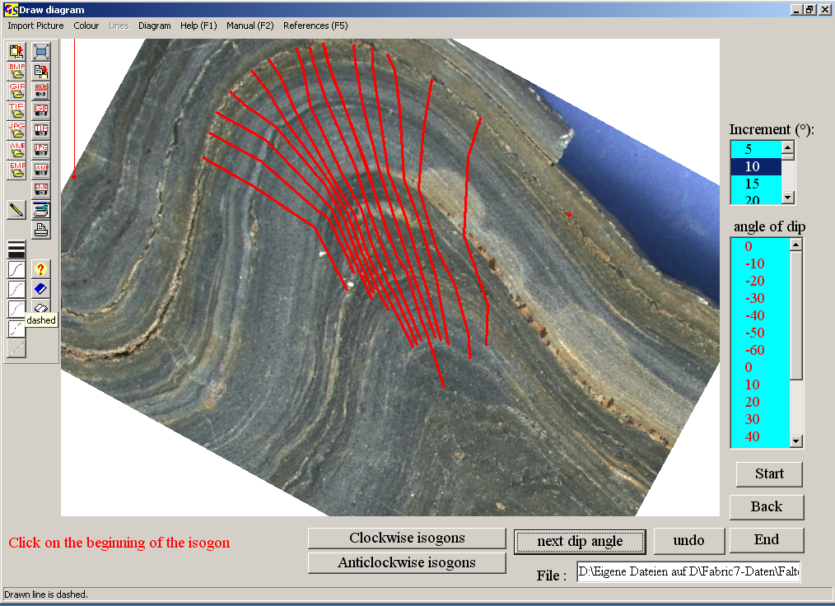
Fig. 5
The options of the menu "Diagram" are explained in program 3.

